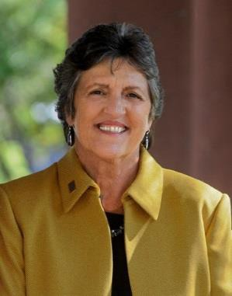
Judith Bense Bio Biography
Judith A. Bense, Ph.D.
President Emeritus and Professor of Anthropology
University of West Florida

Dr. Judith Bense is a native of Panama City, Florida and continues to operate the family farm with her brother Allan. Judy always wanted to be an archaeologist, and earned her first two degrees in Anthropology- Archaeology from Florida State University: a Bachelor of Science in 1967 and a Masters of Arts in 1969. Bense then earned her PhD in Anthropology from Washington State University in 1972.

For the next five years,Dr. Bense had to return to Panama City to take care of the family after the sudden death of their parents. In 1977, she joined the University of West Florida as an adjunct in 1977, then joined University of Alabama as a research archaeologist in 1978, and finally re- joined UWF as a research archaeologist in 1980.

Her career goal at UWF was to find a way to build a nationally recognized Anthropology and Archaeology program from scratch that focused on West Florida's rich but unstudied archaeological sites. She founded the UWF program of Anthropology/Archaeology in 1980, becoming the first academic chair in 2001. This program is one of the most robust in the country and focuses on Northwest Florida and includes a strong shipwreck program. Dr. Bense also established the Archaeology Institute in 1980 and served as its director for 20 years. She has authored five books and 17 chapters in books and professional journals. She was awarded more than 75 grants and contracts totaling more than $6 million. In 2006, she founded the statewide Florida Public Archaeology Network (FPAN), which is headquartered at UWF. FPAN is the largest statewide organization dedicated to bringing archaeology to the general public in the United States. One of the keys to success has been sharing the discoveries with the public and incorporating public volunteers in every aspect of archaeology.

In 2008, Dr. Bense was asked to serve as an Interim President of UWF for nine months while the Trustees conducted a search for a replacement. The Trustees then selected Bense as the 5th UWF President and her term lasted until December 31, 2017 when she requested to step down to complete an interrupted archaeological research book. As President, Bense focused on growth, visibility, enhancing the student “collegiate” experience, and partnerships with the goal of making UWF a first choice university. She built a solid network of community partners, identified regional workforce needs, increased student residents and athletics (including starting football)and strengthened the relationship between the community and university.

Dr. Bense is now President Emeritus and member of the ***is on a sabbatical, making the transition from the Presidency and reconnecting with archaeology. In January 2018, she will re-join the Anthropology and Archaeology program as a Professor and finish up the book on the early 18th Century Spanish occupation of Pensacola and West Florida.

